**1. What does RGBA stand for?**

**Ans:** **RGBA** is a four-channel format containing data for Red, Green, Blue, and an Alpha value. Where Alpha Represents the Opacity

**2. From the Pillow module, how do you get the RGBA value of any images?**

**Ans: ImageColor.getcolor()** gives rgba value of any image

**3. What is a box tuple, and how does it work?**

**Ans:** A box tuple is a tuple value of four integers: the left-edge x-coordinate, the top-edge y-coordinate,the width, and the height, respectively.

**4. Use your image and load in notebook then, How can you find out the width and height of an Image object?**

**Ans:** 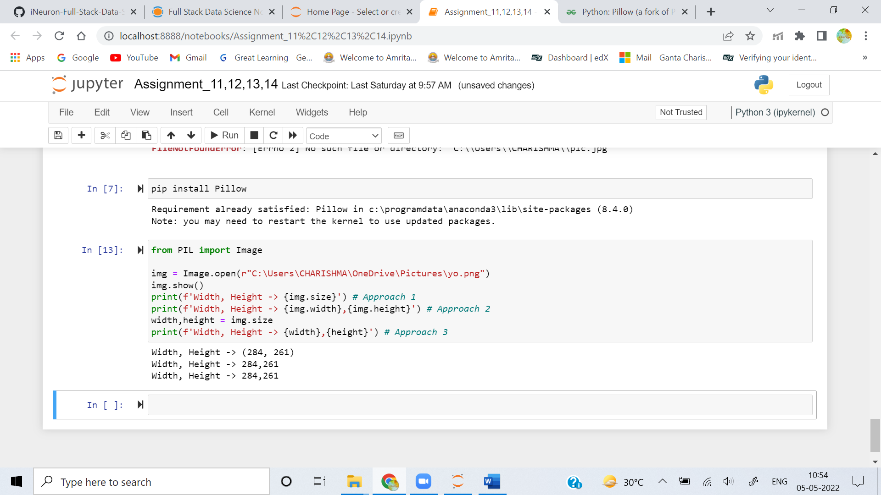

**5. What method would you call to get Image object for a 100×100 image, excluding the lower-left quarter of it?**

**Ans:** 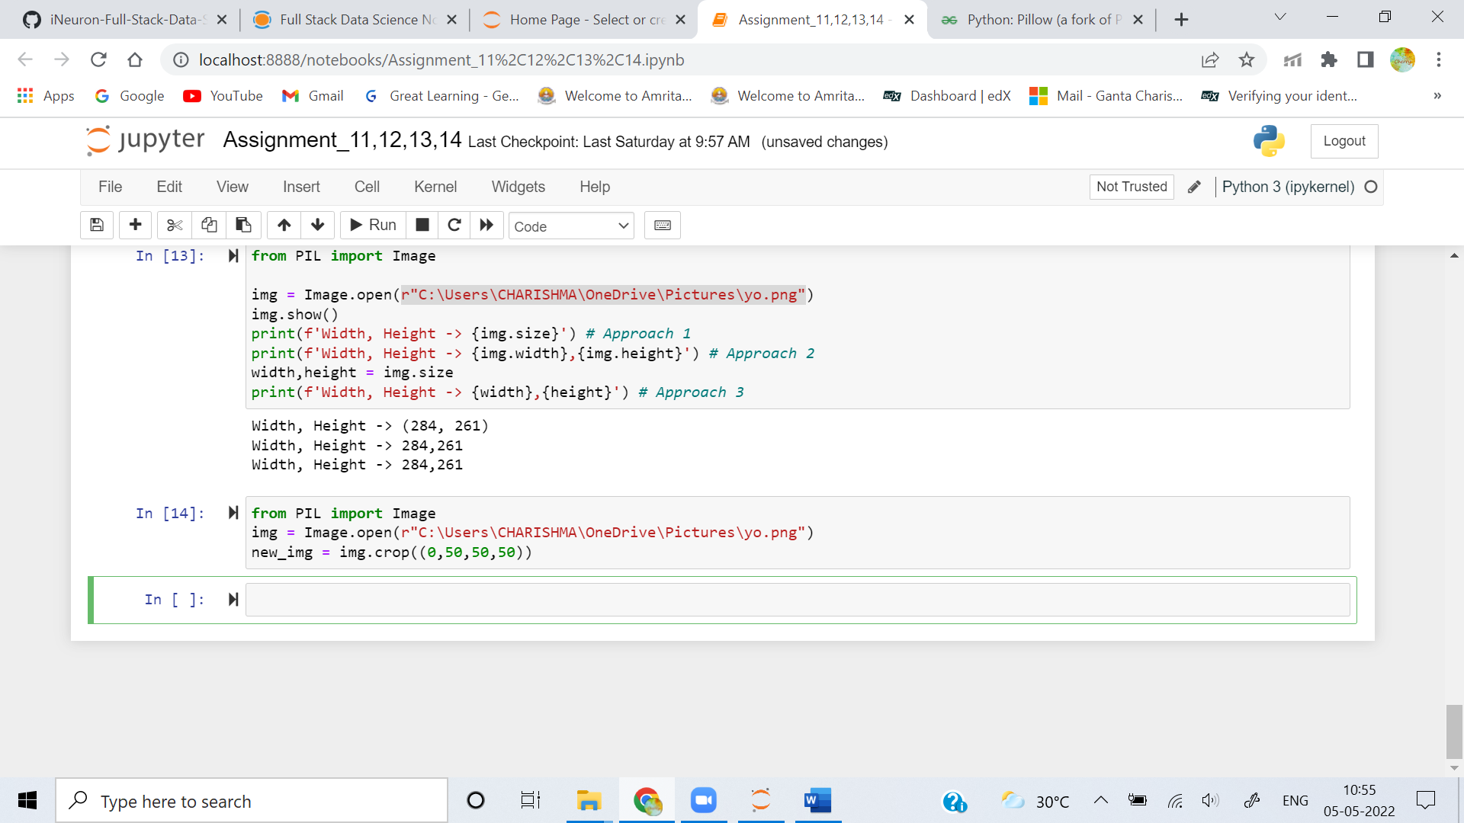

**6. After making changes to an Image object, how could you save it as an image file?**

**Ans:** 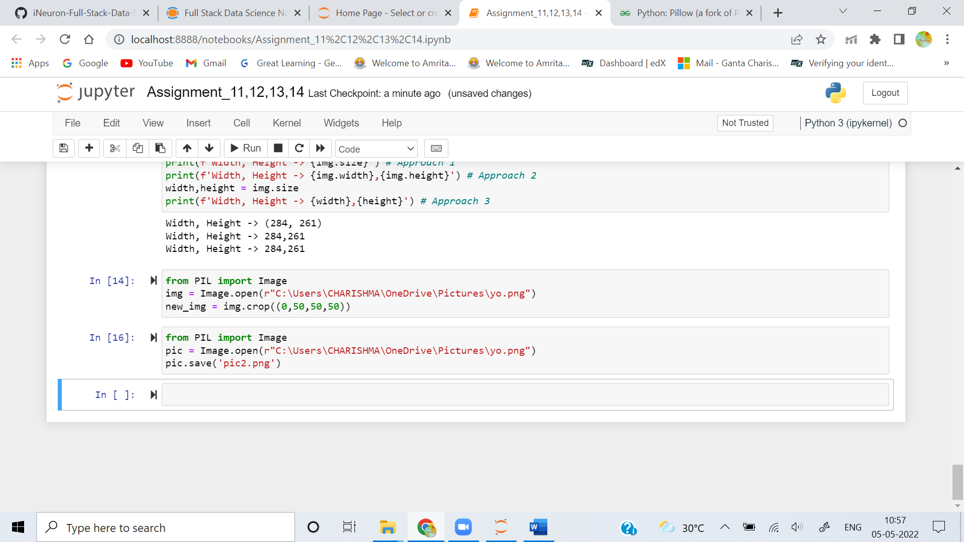

**7. What module contains Pillow’s shape-drawing code?**

**Ans:**  Pillows **ImageDraw** module contains Shape drawing methods

**8. Image objects do not have drawing methods. What kind of object does? How do you get this kind of object?**

**Ans:** ImageDraw objects have shape-drawing methods such as point(), line(), or rectangle().They are returned by passing the Image object to the ImageDraw.Draw() function.